Guidelines for poster presentation
“7th International Environmental Chemistry Congress” 18-20 December 2025, İstanbul, TÜRKİYE

As a poster presenter, we would like to inform you about the details concerning the presentation of your poster at the conference.

Presentation
- The poster boards will be portrait and the sizes of the boards will be: 70 cm x 90 cm.
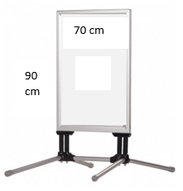
- During the conference, participants will have the opportunity to visit the poster presentations.
- Please print out your posters before you’ve come to the symposium hall.

